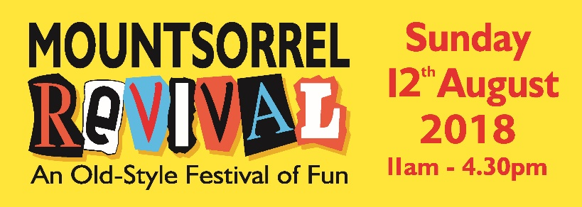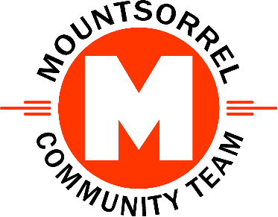

Advertisers Package
- We will place your advert in our free REVIVAL programme:
  - Your advert will be printed in black & white and sized at 56mm by 36 mm. Note: all programme adverts are black &white and to these dimensions other than the programme sponsor’s advert.
  - Your advert will be to your own design. We can arrange the advert artwork for you if required.
  - We will print a minimum of 2000 copies of the REVIVAL programme. These will be given away free of charge at or before the Event. The programme will also be free to download from our website.
- If you chose our Advert Plus package, then we will place your advert on our MCT website until at least 31 March 2019.
  - If you choose, we can link your web advert to your own website or Facebook page.

Prize Providers Package
- In return for you providing one or more prizes for one of our REVIVAL competitions we will:
  - Clearly mark the prizes and any associated certificates with your name.
  - Thank you for providing the prizes on a page titled Our Thanks Go To in the REVIVAL programme. We will print a minimum of 2000 copies of the REVIVAL programme. These will be given away free of charge at or before the Event. The programme will also be free to download from our website.

Advertisers Terms and Conditions
- In this document:
  - ‘We’ or ‘Us’ or ‘Our’ refers to the Mountsorrel Community Team as Organisers.
  - ‘You’ or ‘Your’ refers to the person or organisation placing an order for an Advert.
  - ‘The Event’ refers to the Mountsorrel REVIVAL 2018 which will be held between 11:00 and 16:30 on Sunday 12th August 2018 in the old part of the village of Mountsorrel in Leicestershire.
- You agree to pay us the Advert fee when placing your order.
  - By paying the Advert fee you agree to these Terms & Conditions
- We will limit the total number of Adverts in the REVIVAL programme to 50 and place no more than 4 adverts on each A5 page.
- We reserve the right to cancel the Event in extreme circumstances.
  - If the Event is cancelled due to Force Majeure we will still publish your advert in the Free REVIVAL Programme, many of which are given away before the Event. If you have chosen our Advert Plus package your advert will still appear on our website until at least 31 March 2019.
  - Force Majeure is defined as anything outside of our control which would jeopardise the safety of visitors, attraction providers or stall holders if the Event went ahead. It also includes orders to cancel the event from an official body such as the police or government.
End of Document.

