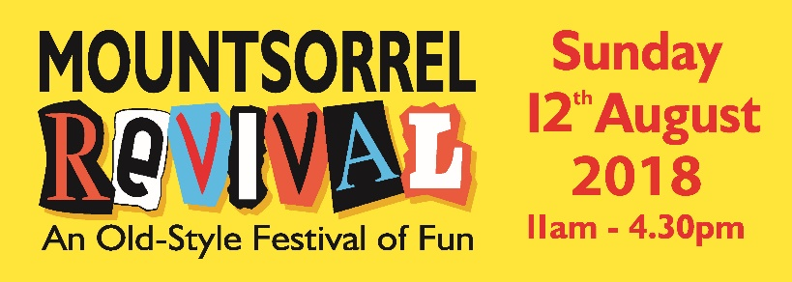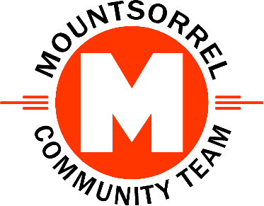

REVIVAL 2018 Sponsorship Agreement
The following sponsorship agreement is made between:
Role | Business or Organisation | Authoriser’s Name | Signature | Date | Type of Sponsorship and Agreed Amount
Sponsor | insert Sponsor’s Name |  |  |  | e.g. Silver / £250
REVIVAL 2018 Organisers | The Mountsorrel Community Team

Sponsorship Packages

Silver Sponsorship Package (Minimum Amount £250)
- We will erect your banner for you at REVIVAL:
  - We will erect your banner inside the new REVIVAL Arena.
  - Your banner may be up to a maximum of 2 square metres in size.
  - We will take down and return your banner to you after the event. Alternatively, we can arrange safe storage if you intend to sponsor us on an annual basis.
  - Banners must be sourced by you to your own design. If you need a banner making we can recommend a professional sign maker who gives preferable rates for REVIVAL. Just let us know.
  - For safety banners must be made of vinyl (or similar), fitted with eyelets and suitable for outdoor use.
  - We will take care of your banner but we are not liable for any damage caused to your banner during the Event.
- We will place your advert in our free REVIVAL programme:
  - Your advert will be printed in black & white and sized at 56mm by 36 mm. Note: all programme adverts are in black and white and to these dimensions other than the programme sponsor’s advert.
  - We will place your advert on our MCT website until a minimum of 31 March 2019.
  - Optionally we can link your web advert to your own website or Facebook page.
  - Your advert will be to your own design. We can arrange the advert artwork for you if required.
  - We will print a minimum of 2000 copies of the REVIVAL programme. These will be given away free of charge at or before the Event. The programme will also be free to download from our website.
- We will officially thank you for sponsoring the Mountsorrel REVIVAL 2018 under the title Our Thanks Go To in the REVIVAL programme. Sponsors are listed first in this section.

Gold Sponsorship (Minimum Amount £400)
- Our Gold Sponsorship Package includes all the benefits of our Silver package, except that your banner will be exclusively displayed at the Music Stage in the Market Place.
- The music stage will feature acts throughout the day will be renamed as the <<Sponsor’s Name>> Music Stage for the event.
  - The Music Stage compère will use this name throughout the activities on the Music Stage.
  - The Music Stage will be referred to by this name in the free printed Programme.
- You will be allocated a standard pitch alongside the music stage which you can (optionally) use to advertise your company or organisation.

Platinum Sponsorship (Minimum Amount £500)
- Our Platinum Sponsorship Package includes all the benefits of our Silver package.
- The REVIVAL Arena which will feature various items during REVIVAL will be known as the <<Sponsor’s Name>> Arena for the duration of the Event.
  - The Arena compère will use this name throughout the activities in the Arena.
  - The Arena will be referred to by this name throughout the free printed Programme.
- You will be allocated a standard pitch alongside the Arena which you can (optionally) use to advertise your company or organisation.

Programme Sponsorship (Minimum Amount £350)
- We will place your full-page sponsor’s advert in the free REVIVAL programme.
  - Your advert will 148mm by 210mm (A5). That’s more than 15 times larger than each of the other adverts in the programme.
  - Your advert will be in full-colour. All other adverts are in black & white.
  - You may choose where your advert appears. Only the front and centre pages are reserved.
  - Your advert will be to your own design. We can arrange the artwork for you if required.
  - We will print a minimum of 2000 copies of the REVIVAL programme. These will be given away free of charge at or before the Event. The programme will also be free to download from our website.
- We will officially thank you for sponsoring the Mountsorrel REVIVAL 2018 under the title Our Thanks Go To in the REVIVAL programme. Sponsors are listed first in this section.

Sponsorship Terms and Conditions
- In this agreement:
  - ‘We’ or ‘Us’ or ‘Our’ refers to the Mountsorrel Community Team as Organisers.
  - ‘You’ or ‘Your’ refers to the Sponsor named above as a sponsor of Mountsorrel REVIVAL 2018.
  - ‘The Event’ refers to the Mountsorrel REVIVAL 2018 which will be held between 11:00 and 16:30 on Sunday 12th August 2018 in the old part of the village of Mountsorrel in Leicestershire.
- The agreed fee for your sponsorship will be entered in the authorisation section above.
  - You must pay the agreed fee at least 30 days before the Event.
  - By paying the Sponsorship fee you agree to these Terms & Conditions
  - In return for your sponsorship we will provide the services determined by Type of Sponsorship entered in the authorisation section and detailed in the Sponsorship Packages section.
- We are a not-for-profit community organisation and so we will use your sponsorship money to:
  - Further improve safety at our event e.g. by closing more roads.
  - Provide more attractions for visitors.
  - Pay standing costs like insurance and printing so that we can keep the event free for all visitors.
- We will limit the total number of sponsors of the Event to a maximum of 10 (ten).
- We reserve the right to cancel the Event in extreme circumstances.
  - If the Event is cancelled due to Force Majeure we will still publish your advert in the free REVIVAL Programme, many of which are given away before the Event. We will also still publish your advert on our website until at least 31 March 2019. We will use your banner at another MCT Event.
  - Force Majeure is defined as anything outside of our control which would jeopardise the safety of visitors, attraction providers or stall holders if the Event went ahead. It also includes orders to cancel the event from an official body such as the police or government.

End of Document.

